

**Database Management System**

**Project**

(BANK MANAGEMENT SYSTEM)

By

**Ahan Bandyopadhyay (211210008)**

**Gaurav Singh (211210024)**

**Kanha Madan (211210031)**

**CONTENTS**

1. INTRODUCTION

2. CASE STUDY

3. REQUIREMENT ANALYSIS

4. HARDWARE AND SOFTWARE REQUIREMENTS

5. ER DIAGRAM

6. ER->R MAPPING

7. SQL QUERIES

8. DB CONNECTIVITY

9. FRONT END

10. BIBLOGRAPHY

**INTRODUCTION**

* The bank management system is a set of essential tools and processes that allow banks and their credit institutions to carry out their functions.
* The components of the bank management system may differ depending on the bank, but generally, the system includes core banking to manage basic transactions, loans, mortgages, and payments accessible via ATM, mobile banking, and branches.
* Database Management is the core of modern data, as handling and managing data is the key to making exponential progress in today’s world.

Here, the undersigned students of CSE 2nd year:

1. AHAN BANDYOPADHYAY (211210008)

2. GAURAV SINGH (211210024)

3. KANHA MADAN (211210031)

Have completed a project on the Database of the Bank Management System which cites all the information.

* 1. **Project objective**

**.** To allow only authorized user to access various function and processed available in the system.

**.** Locate any A/C wanted by the user.

**.** Reduced clerical work as most of the work done by computer.

**.** Provide greater speed & reduced time consumption.

* 1. **Project benefits**
* To save time and make better accounting system.
* To increase efficiency of employees.
* For faster access of data and information.
* For smooth and fair running of the organization.
* To manipulate the banking transaction with instant confirmation for the withdrawal, deposit, loan etc.
  1. **Project scope**

Banking activities are considered to be the life blood of national economy. Without banking services, trading and business activities cannot be carried on smoothly. Banks are the distributors and protectors of liquid capital which is of vital significance to a developing country.

Efficient administration of the banking system helps in the economic Growth of the nation. Banking is useful to trade and commerce.

**Software requirements:**

In the development of a project the selection of an appropriate DBMS Software and a platform is of primary importance. With many software options available a developer has to consider the various features and functionalities and ease of handling the software, keeping an account of such things we decided to use Bootstrap Studio for designing the front-end, the front-end has been developed by the use of HTML, CSS and JS. MySQL has been used as a back-end query language. PHP has been chosen as a scripting language. The server chosen is the localhost which would be hosting the website on the machine itself.

**ER DIAGRAM**

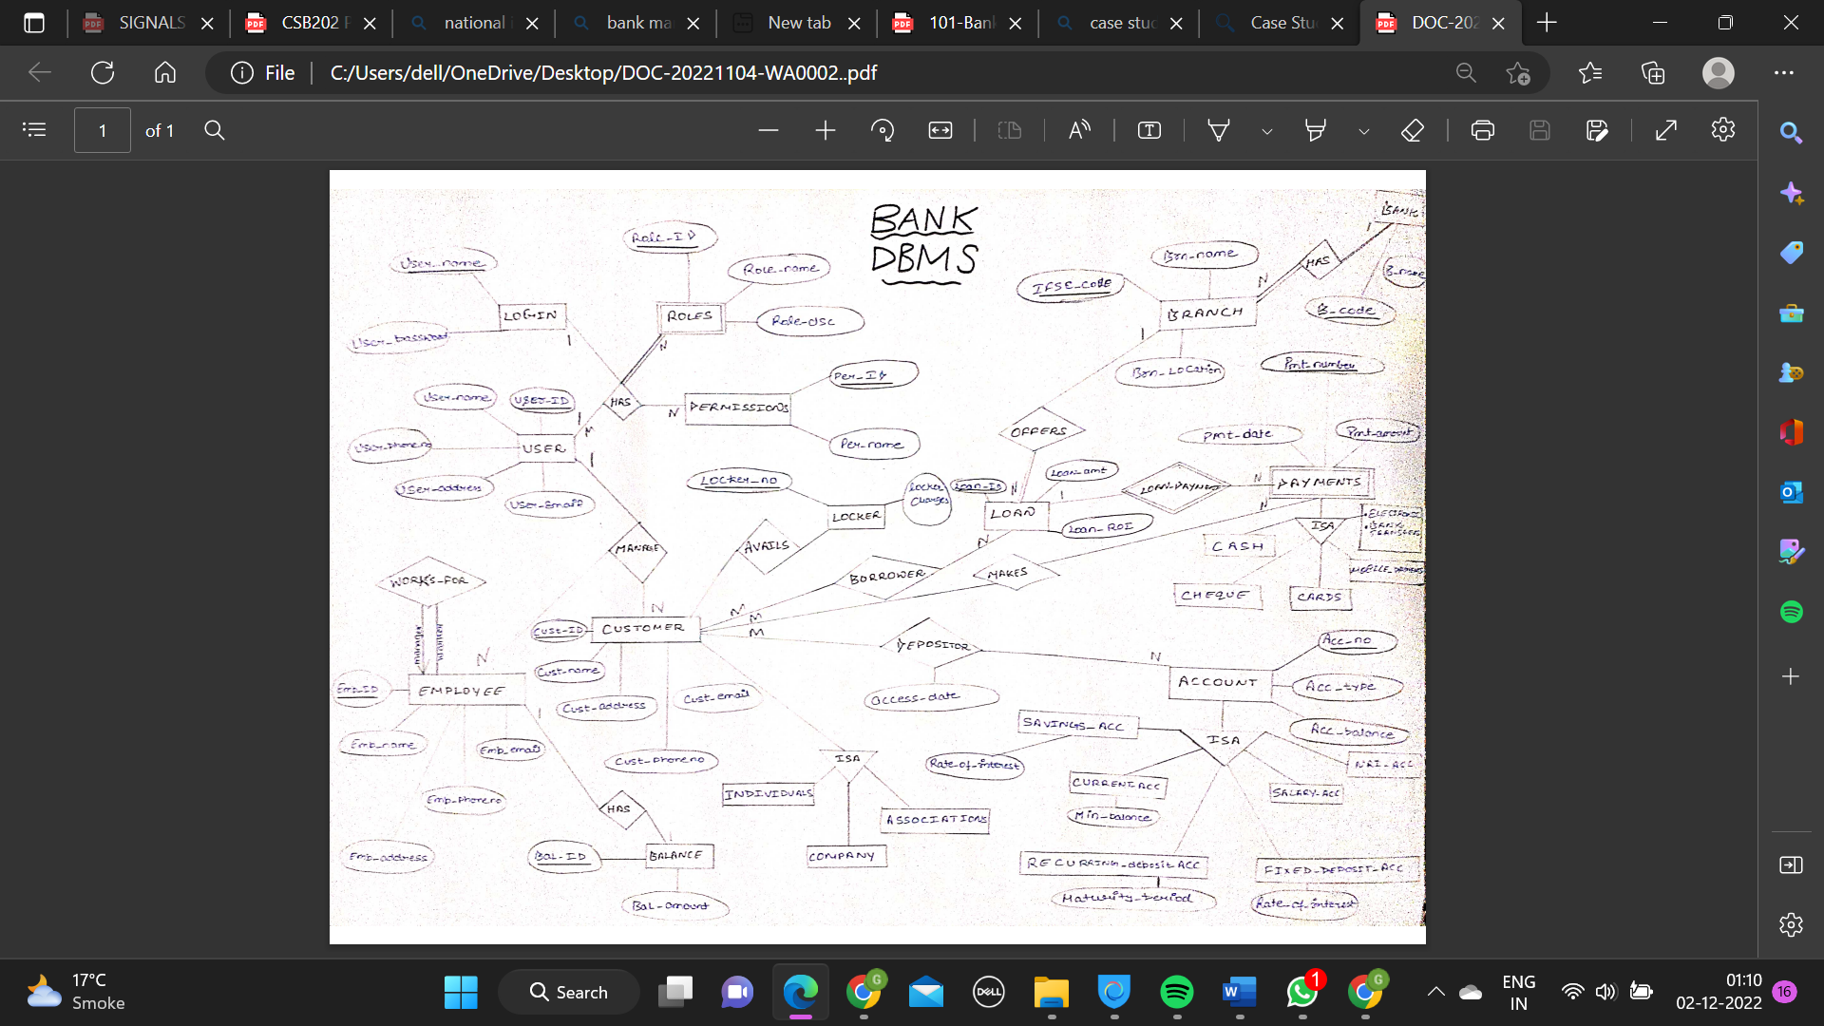

**MAPPING ER->RDBMS MODEL**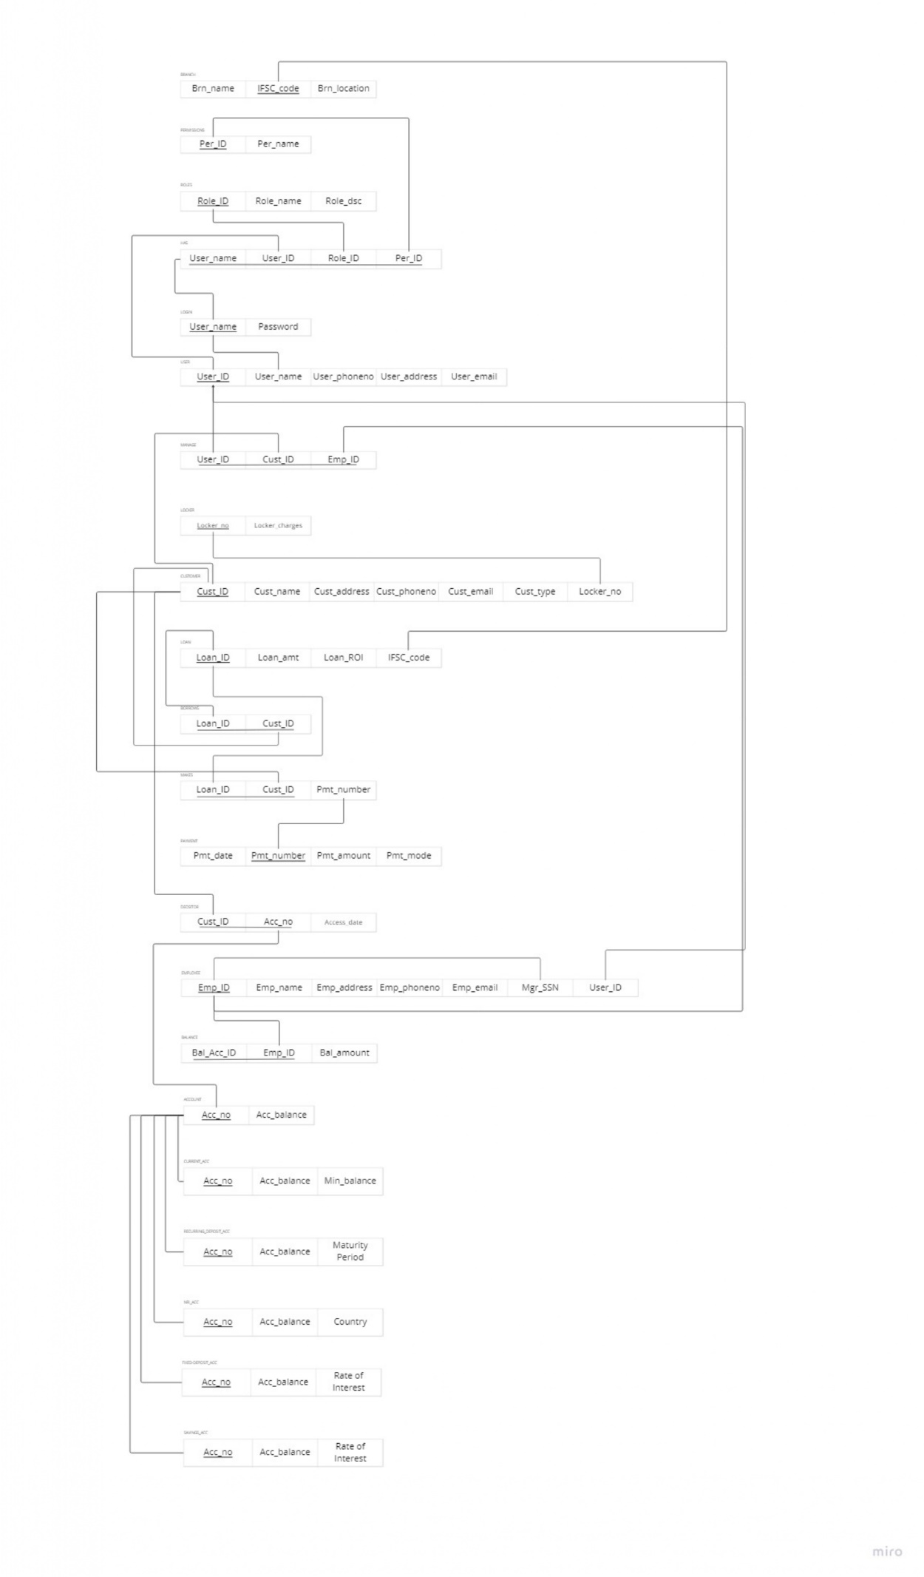

**CREATION Table queries:**

create database bank;

use bank;

create table roles

(

Role_ID char(10) not null,

Role_name varchar(30),

Role_dsc varchar(30)

);

use bank;

create table permissions

(

Per_ID char(10) not null,

Per_name varchar(30)

);

use bank;

create table locker

(

Locker_no char(10) not null,

Locker_charges int

);

use bank;

create table locker

(

Locker_no char(10) not null,

Locker_charges int

);

use bank;

create table makes

(

Loan_Id char(10) not null,

Cust_ID char(10) not null,

Pmt_number char(10) not null

);

use bank;

create table borrows

(

Loan_Id char(10) not null,

Cust_ID char(10) not null

);

use bank;

create table branch

(

Brn_name varchar(20),

IFSC_code char(10) not null,

Brn_location varchar(50)

);

use bank;

create table payment

(

Pmt_date date,

Pmt_number char(10) not null,

Pmt_amount int,

Pmt_mode varchar(30)

);

use bank;

create table depositor

(

Cust_ID char(10) not null,

Acc_no char(10) not null,

Access_date date

);

use bank;

create table savings_acc

(

Acc_no char(10) not null,

Acc_balance bigint,

Rate_of_interest int

);

use bank;

create table current_acc

(

Acc_no char(10) not null,

Acc_balance bigint,

Min_balance int

);

use bank;

create table recurring_deposit_acc

(

Acc_no char(10) not null,

Acc_balance bigint,

Maturity_period int

);

use bank;

create table fixed_deposit_acc

(

Acc_no char(10) not null,

Acc_balance bigint,

Rate_of_interest int

);

use bank;

create table NRI_acc

(

Acc_no char(10) not null,

Acc_balance bigint,

country varchar(30)

);

use bank;

create table balance

(

Bal_Acc_ID char(10) not null,

Emp_ID char(10) not null,

Bal_amount bigint

);

use bank ;

create table manage

(

User_ID char(10) not null,

Cust_ID char(10) not null,

Emp_ID char(10) not null

);

use bank;

create table has

(

User_name char(30) not null unique,

User_ID char(10) not null,

Role_ID char(10) not null,

Per_ID char(10) not null

);

use bank;

create table employee

(

Emp_ID char(10) not null,

Emp_name char(30),

Emp_address varchar(50),

Emp_phoneno bigint,

Emp_email varchar(30),

Mgr_SSN char(10) not null

);

use bank;

insert into login

values

('abc001', '123abc'),

('def002', '456def'),

('ghi003', '789ghi'),

('abcd_1', '123abcd'),

('efgh_2', '456efgh'),

('ijkl_3', '789ijkl');

use bank;

create table user

(

User_ID char(10) not null,

User_name char(30) not null unique,

User_phoneno bigint,

User_address varchar(50),

User_email varchar(30)

);

use bank;

create table account

(

Acc_no char(10) not null,

Acc_balance bigint

);

use bank;

create table customer

(

Cust_ID char(10) not null,

Cust_name varchar(30),

Cust_address varchar(50),

Cust_phoneno bigint,

Cust_email varchar(30),

Cust_type varchar(30),

Locker_no char(10) not null

);

use bank;

create table login

(

User_name char(30),

Password varchar(30)

);

**INSERTION queries:**

use bank;

insert into branch

values

('TILAKNAGAR BRANCH','gsr0210395','west delhi'),

('WRIGHTGANJ BRANCH','gsr0210456','south delhi'),

('ALIPUR BRANCH','gsr0210678','north delhi');

use bank;

insert into loan

values

(0201,3000000,0.1,'gsr0210395'),

(1234,4000000,0.095,'gsr0210456'),

(2345,100000,0.085,'gsr0210678');

use bank;

insert into borrows

values

(0201,'abc'),

(1234,'def'),

(2345,'ghi');

use bank;

insert into current_acc

values

(5037720309,25000,1000),

(5147756908,200024,500),

(2314567890,1975308,1);

use bank;

insert into recurring_deposit_acc

values

(5037720309,25000,6),

(5147756908,200024,8),

(2314567890,1975308,10);

use bank;

insert into fixed_deposit_acc

values

(5037720309,25000,2.75),

(5147756908,200024,3.0),

(2314567890,1975308,2.14);

use bank;

insert into NRI_acc

values

(5037720309,25000,'norway'),

(5147756908,200024,'swizerland'),

(2314567890,1975308,'london');

use bank;

insert into makes

values

(0201,'abc',000256),

(1234,'def',000255),

(2345,'ghi',000254);

use bank;

insert into payment

values

('2018-09-20', 000256,4000,'check'),

('2019-03-15', 000255,20000,'cash'),

('2023-12-25',000254,100000,'netbanking');

use bank;

insert into account

values

(5037720309,100000),

(5147756908,1000123),

(2314567890,9876543);

use bank;

insert into depositor

values

('abc',5037720309,'2023-03-12'),

('def',5147756908,'2024-04-13'),

('ghi',2314567890,'2025-05-14');

use bank;

insert into balance

values

('9999', 'abcd', 200000),

('8888', 'efgh', 1000000),

('7777', 'ijkl', 5000000);

use bank;

insert into savings_acc

values

(5037720309,25000,0.001),

(5147756908,200024,0.002),

(2314567890,1975308,0.0003);

use bank;

insert into locker

values

(32,3000),

(315,5000),

(123,2000);

use bank;

insert into user

values

('abc001', 'ahan001', 1234567890, 'narela', 'abc@gmail.com'),

('def002', 'gaurav002', 7291994633, 'south delhi', 'def@gmail.com'),

('ghi003', 'kanha003', 9899140714, 'rohtak', 'ghi@gmail.com'),

('abcd_1', 'varuag01', 9918463280, 'kalkaji', 'abcd@gmail.com'),

('efgh_2', 'aanchal02', 9567438812, 'noida', 'efgh@gmail.com'),

('ijkl_3', 'gsr03', 7865432517, 'chitranjanpark', 'ijkl@gmail.com');

use bank;

insert into customer

values

('abc', 'ahan', 'narela', 1234567890, 'abc@gmail.com', 'individual', 32),

('def', 'gaurav', 'south delhi', 7291994633, 'def@gmail.com', 'individual', 315),

('ghi', 'kanha', 'rohtak', 9899140714, 'ghi@gmail.com', 'individual', 123);

use bank;

insert into employee

values

('abcd','varuag','kalkaji',9918463280,'abcd@gmail.com', 'ijkl'),

('efgh','aanchal','noida',9567438812,'efgh@gmail.com', 'ijkl'),

('ijkl','gsr','chitranjanpark',7865432517,'ijkl@gmail.com', 'ijkl');

**Primary keys declaration:**

use bank;

alter table account add primary key(Acc_no);

alter table balance add primary key(Bal_Acc_ID, Emp_ID);

alter table borrows add primary key(Loan_ID, Cust_ID);

alter table branch add primary key(IFSC_code);

alter table current_acc add primary key(Acc_no);

alter table customer add primary key(Cust_ID);

alter table depositor add primary key(Cust_ID, Acc_no);

alter table employee add primary key(Emp_ID);

alter table fixed_deposit_acc add primary key(Acc_no);

alter table has add primary key(User_name, User_ID, Role_ID, Per_ID);

alter table loan add primary key(Loan_ID);

alter table locker add primary key(Locker_no);

alter table login add primary key(User_name);

alter table makes add primary key(Loan_ID, Cust_ID);

alter table manage add primary key(User_ID, Cust_ID, Emp_ID);

alter table nri_acc add primary key(Acc_no);

alter table payment add primary key(Pmt_number);

alter table permissions add primary key(Per_ID);

alter table recurring_deposit_acc add primary key(Acc_no);

alter table roles add primary key(Role_ID);

alter table savings_acc add primary key(Acc_no);

alter table user add primary key(User_ID);

**Foreign Keys Declarations:**

use bank;

-- alter table customer add foreign key(Locker_no) references locker(Locker_no);

-- alter table manage add foreign key (User_ID) references user(User_ID);

-- alter table manage add foreign key (Cust_ID) references customer(Cust_ID);

-- alter table manage add foreign key (Emp_ID) references employee(Emp_ID);

-- alter table loan add foreign key (IFSC_code) references branch(IFSC_code);

-- alter table borrows add foreign key (Loan_ID) references loan(Loan_ID);

-- alter table borrows add foreign key (Cust_ID) references customer(Cust_ID);

-- alter table makes add foreign key (Loan_ID) references loan(Loan_ID);

-- alter table user add foreign key(User_name) references login(User_name);

-- alter table makes add foreign key (Cust_ID) references customer(Cust_ID);

-- alter table makes add foreign key (Pmt_number) references payment(Pmt_number);

-- alter table depositor add foreign key (Cust_ID) references customer(Cust_ID);

-- alter table depositor add foreign key (Acc_no) references account(Acc_no);

-- alter table employee add foreign key (Mgr_SSN) references employee(Emp_ID);

-- alter table balance add foreign key (Emp_ID) references employee(Emp_ID);

-- alter table current_acc add foreign key (Acc_no) references account(Acc_no);

-- alter table recurring_deposit_acc add foreign key (Acc_no) references account(Acc_no);

-- alter table nri_acc add foreign key (Acc_no) references account(Acc_no);

-- alter table fixed_deposit_acc add foreign key (Acc_no) references account(Acc_no);

-- alter table savings_acc add foreign key (Acc_no) references account(Acc_no);

-- alter table user add foreign key(User_name) references login(User_name);

**SQL queries**

QUERIES TO CREATE THE RELATIONS AND POPULATE DATABASE:

**Basic queries**

**Question 1:** **Retrieve loan details where loan id = 201**

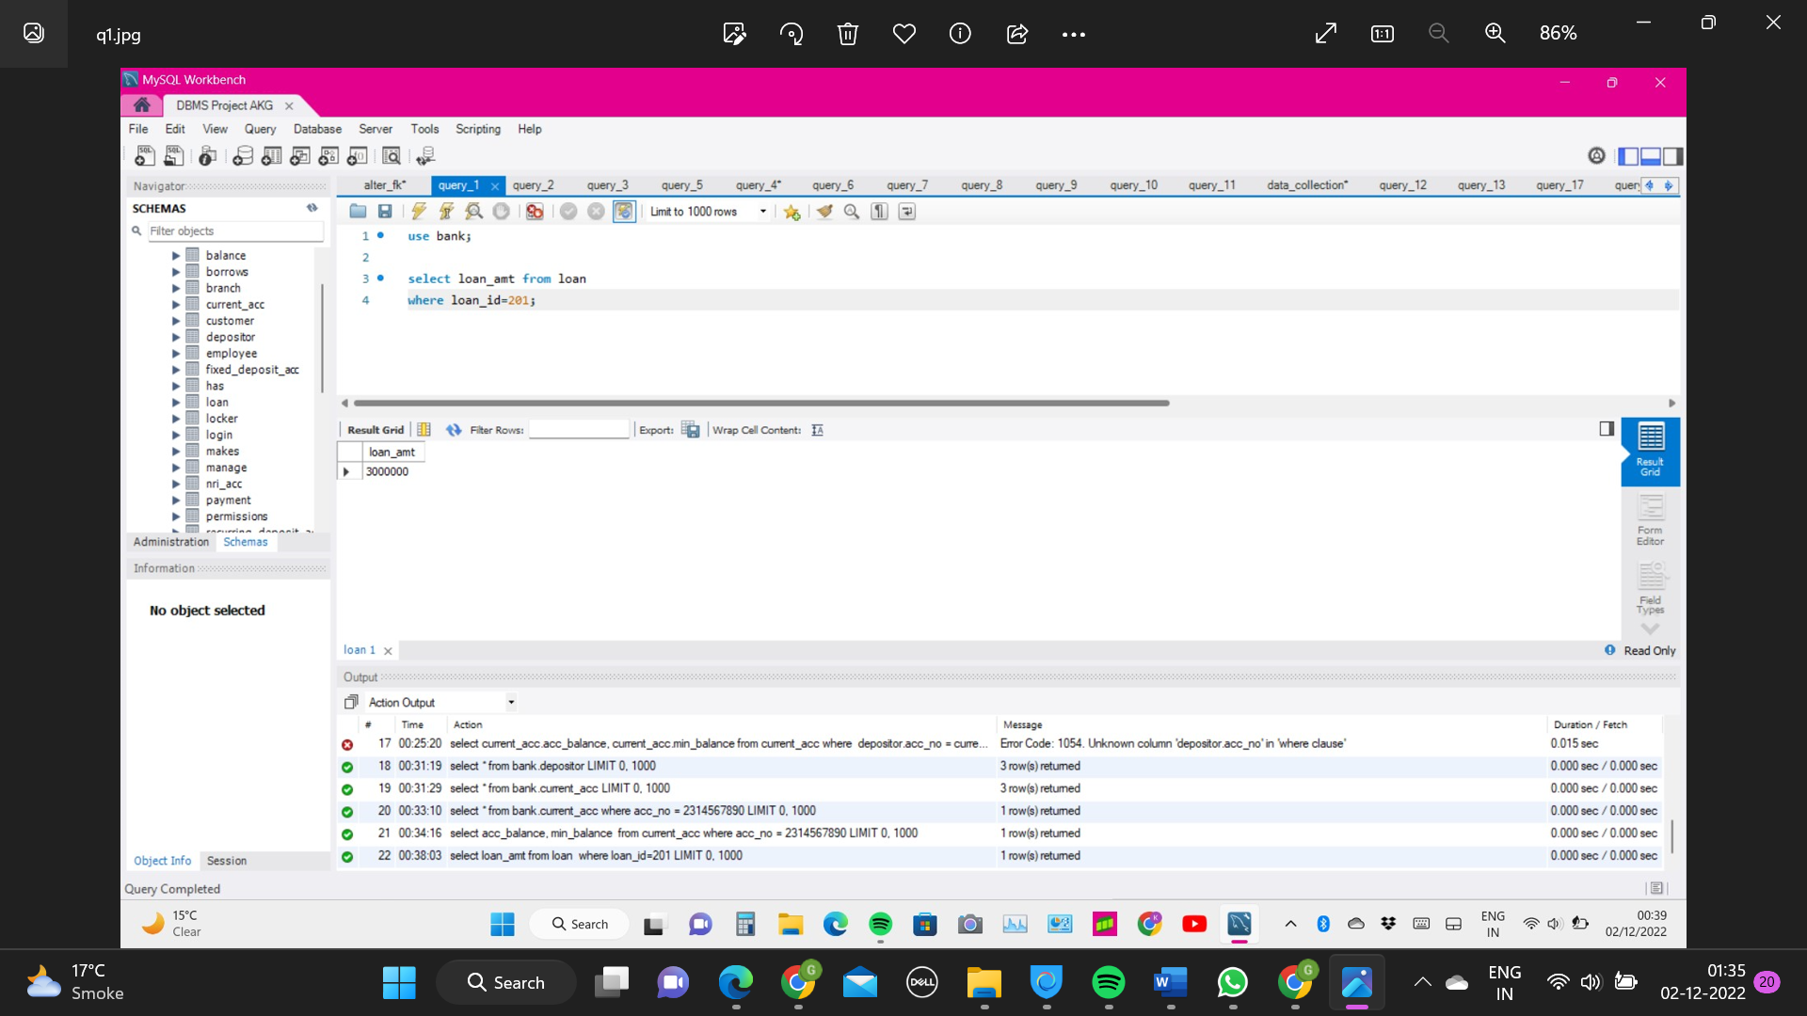

**Question 2:** **Add attribute date of birth (dob) for customer**

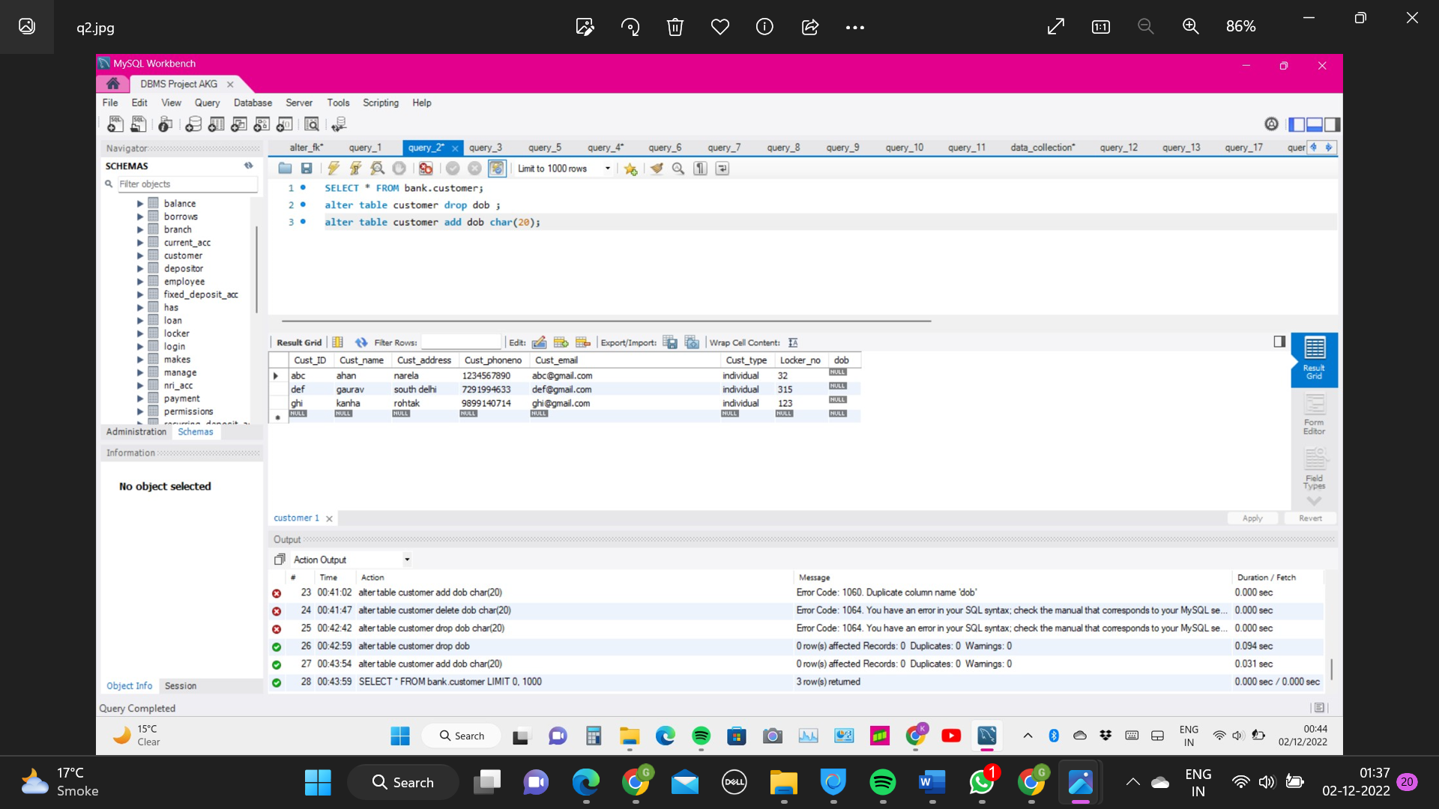

**Question 3:** **Drop attribute dob for customer**

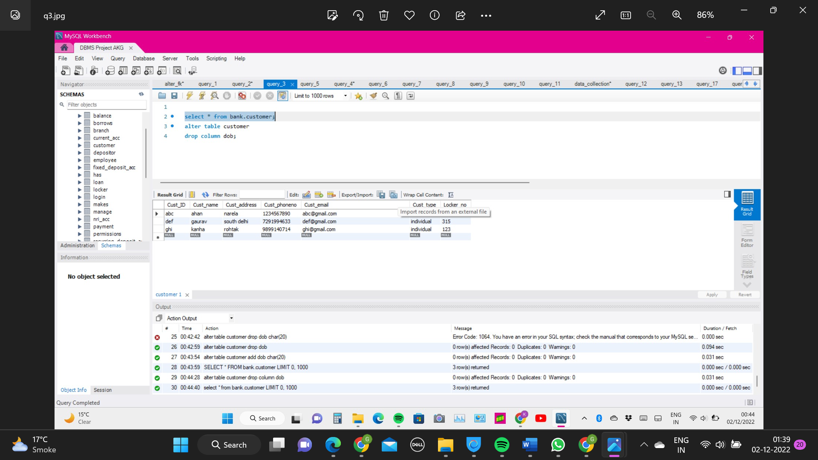

**Question 4:** **Retrieve user details for user having mobile no. = 1234567890 and address = 'Narela'**

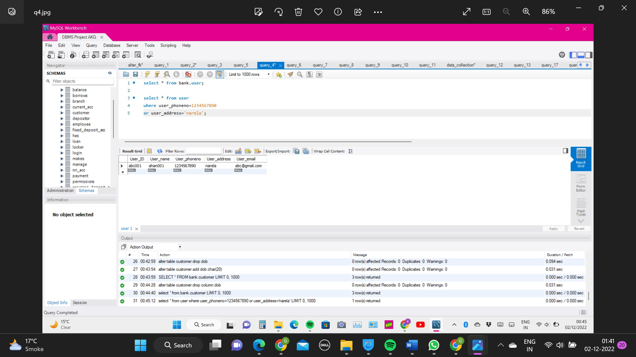

**Question 5:** **Retrieve loan details order by ascending loan amount**

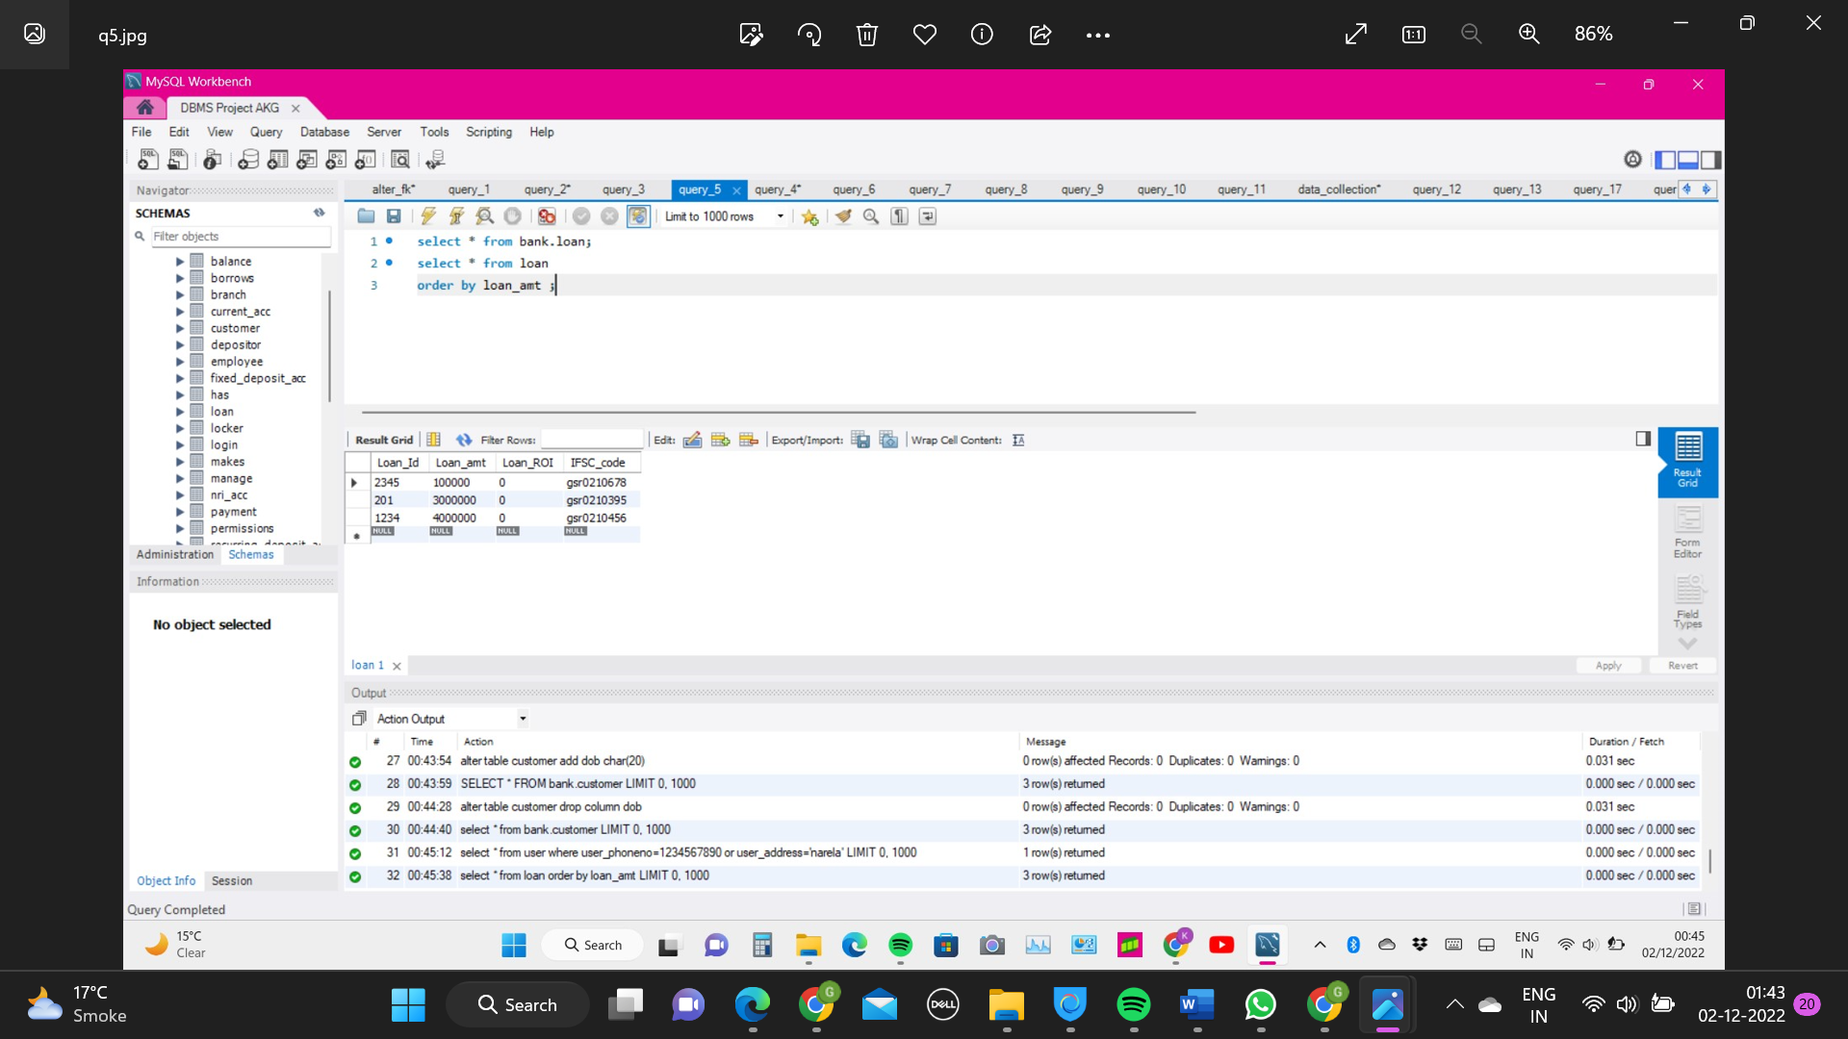

**Question 6: Update name of employee having employee ID = 'ijkl'**

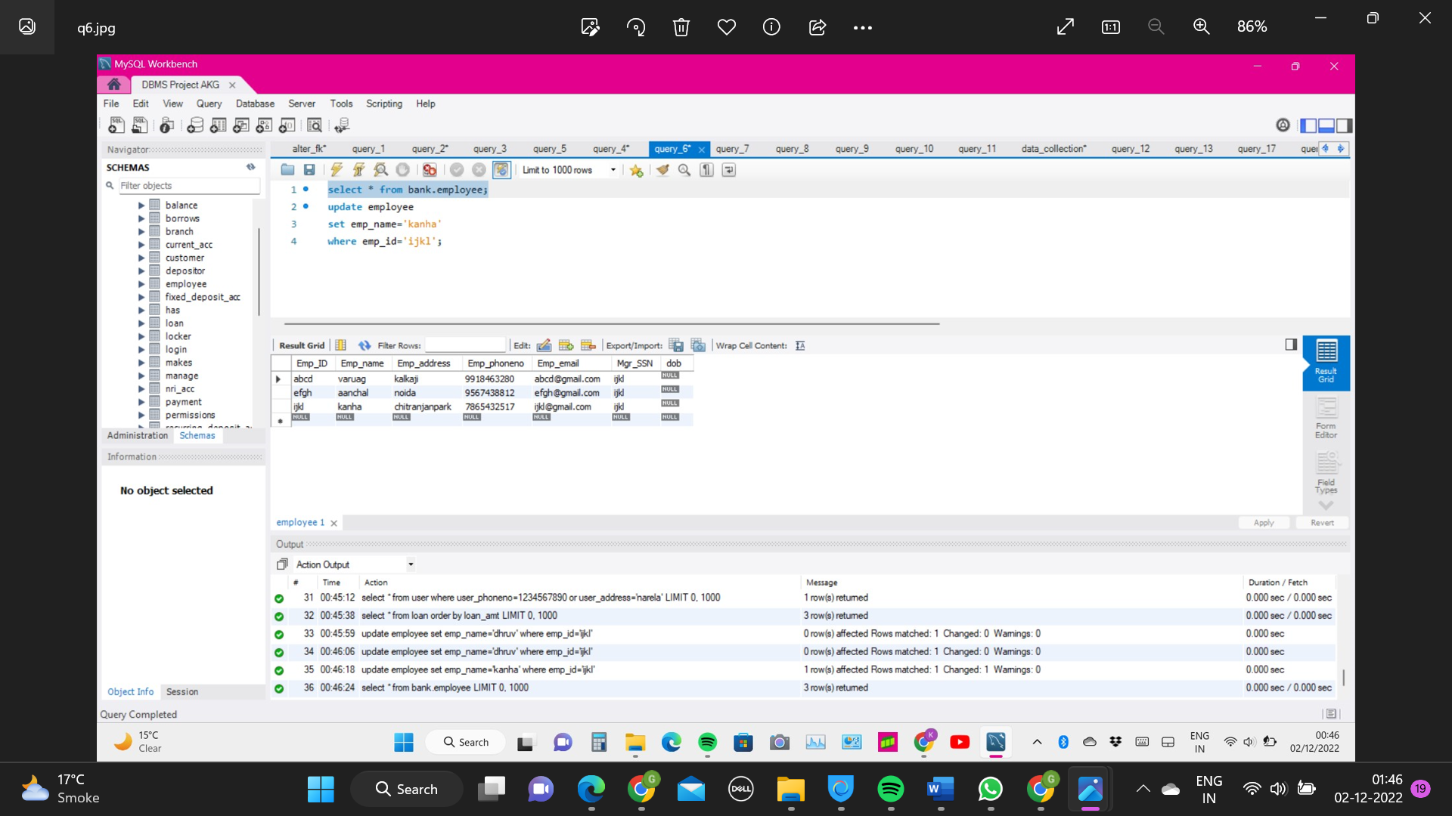

**Question 7:** **Retrieve maximum amount of loan lend by any customer from bank**

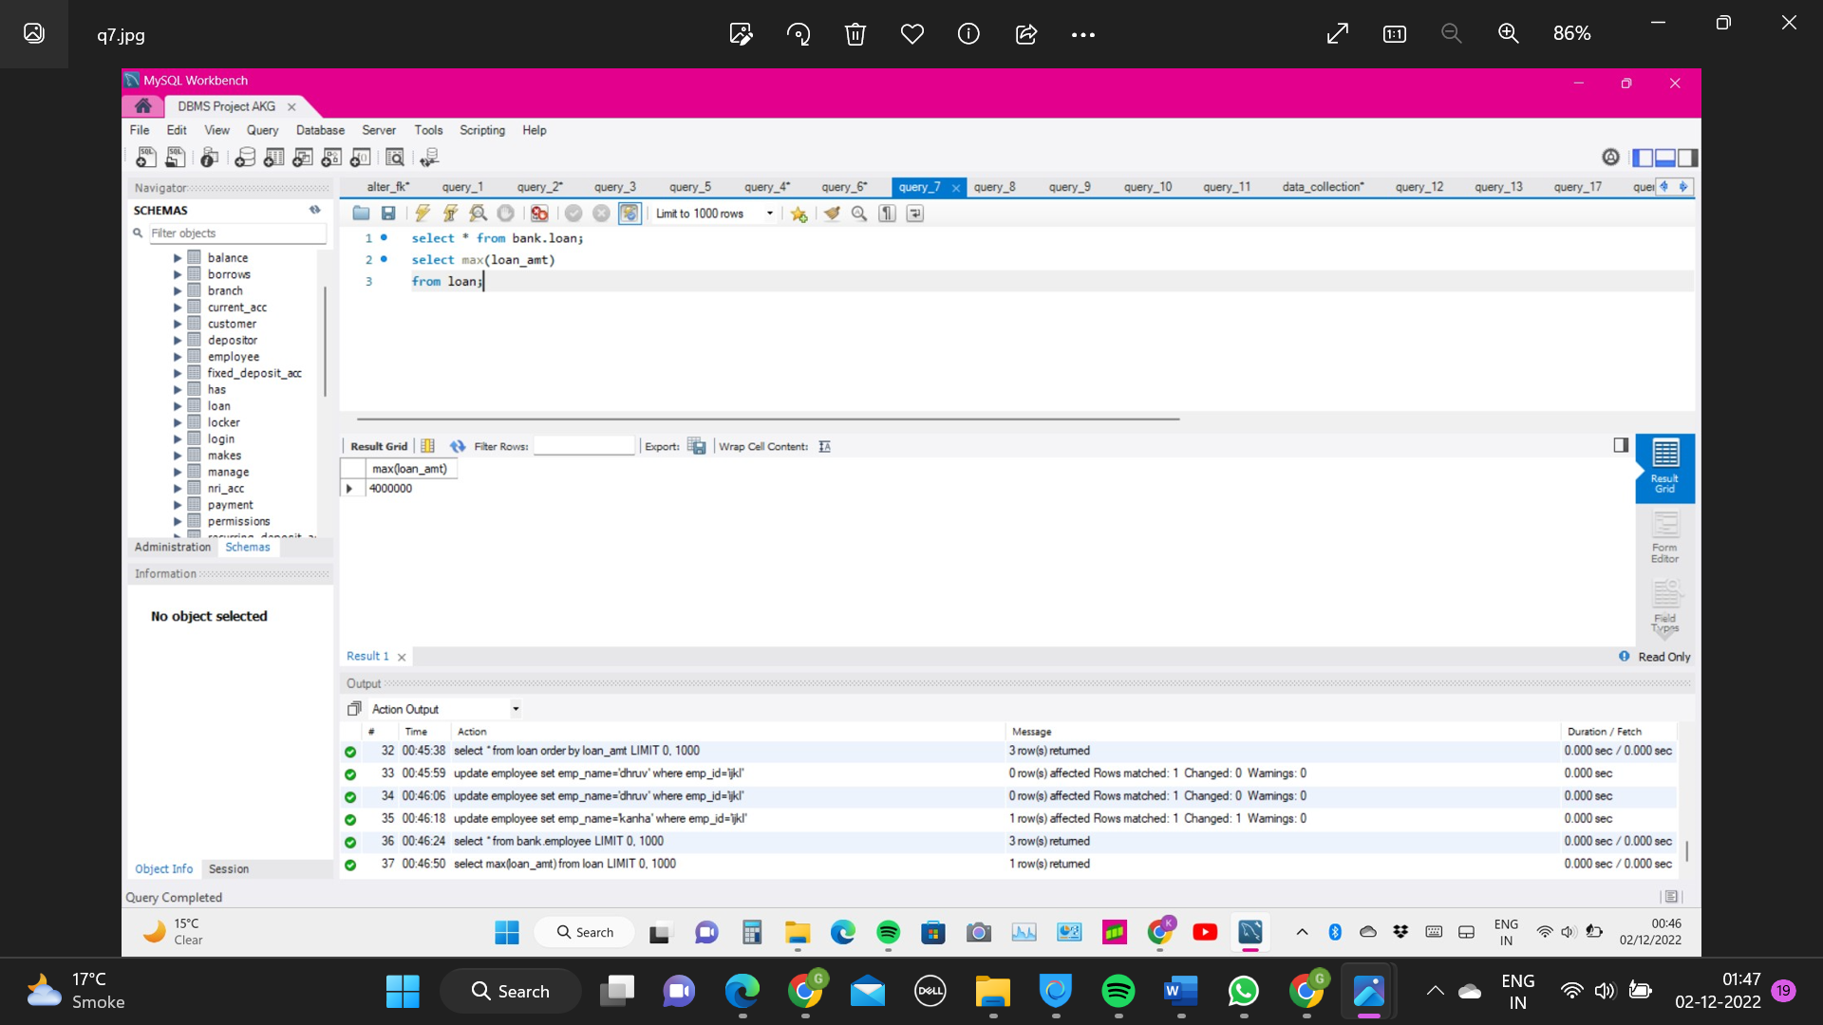

**Question 8:** **Count the distinct users that have taken loan of and above 4000000**

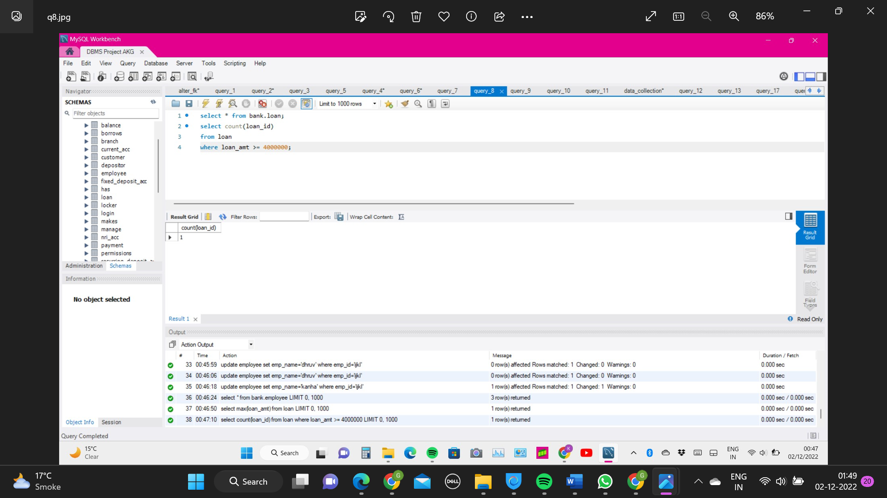

**Question 9:** **Retrieve loan details of user who have lend a loan between 1000000 to 100000000**

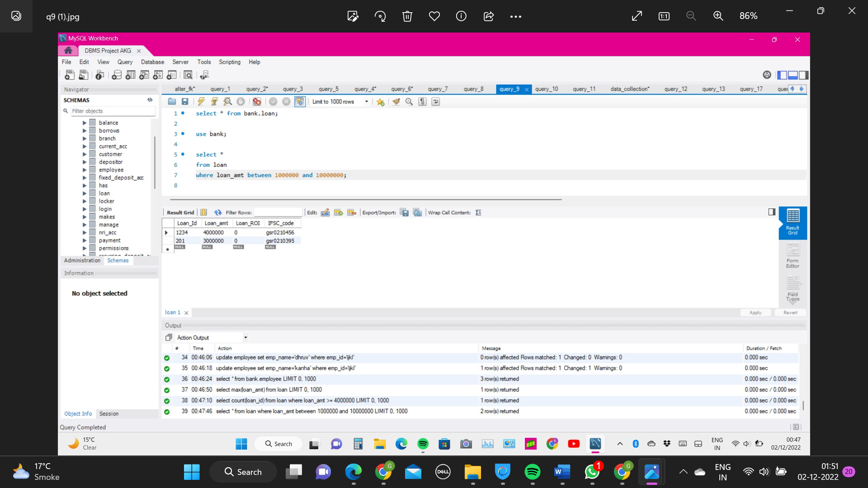

**Question 10:** **Retrieve depositor details for user having 7 in their account no. anywhere**

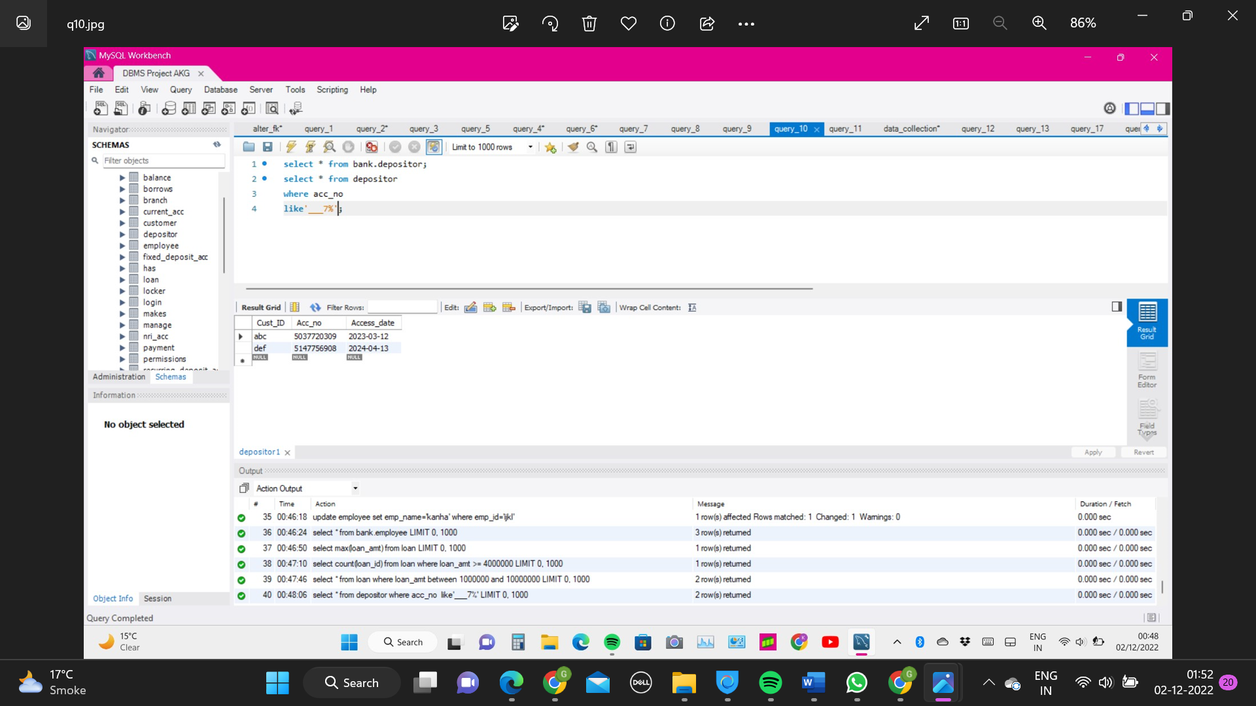

**Question 11:** **Retrieve combine data of employee data and customer table as employee ID , employee names, employee address**

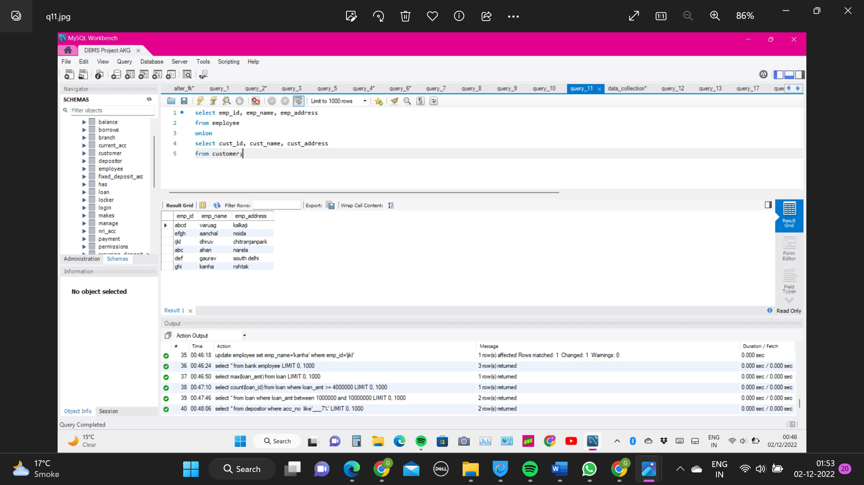

**Question 12:** **Find total amount of payments performed in each payment mode**

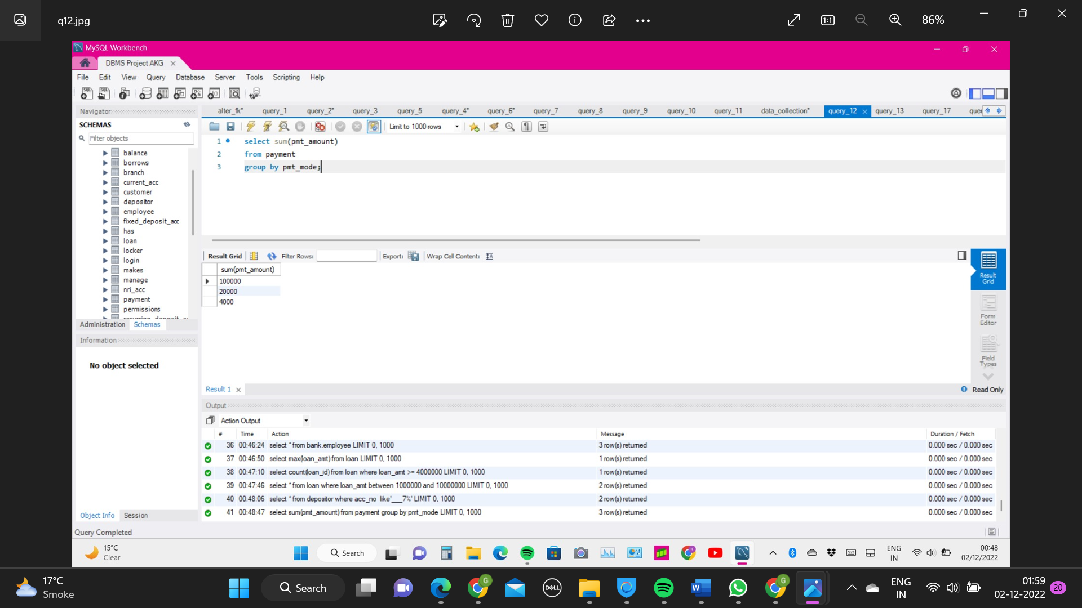

**Question 13:** **Retrieve user details of user having 'a' in their name.**

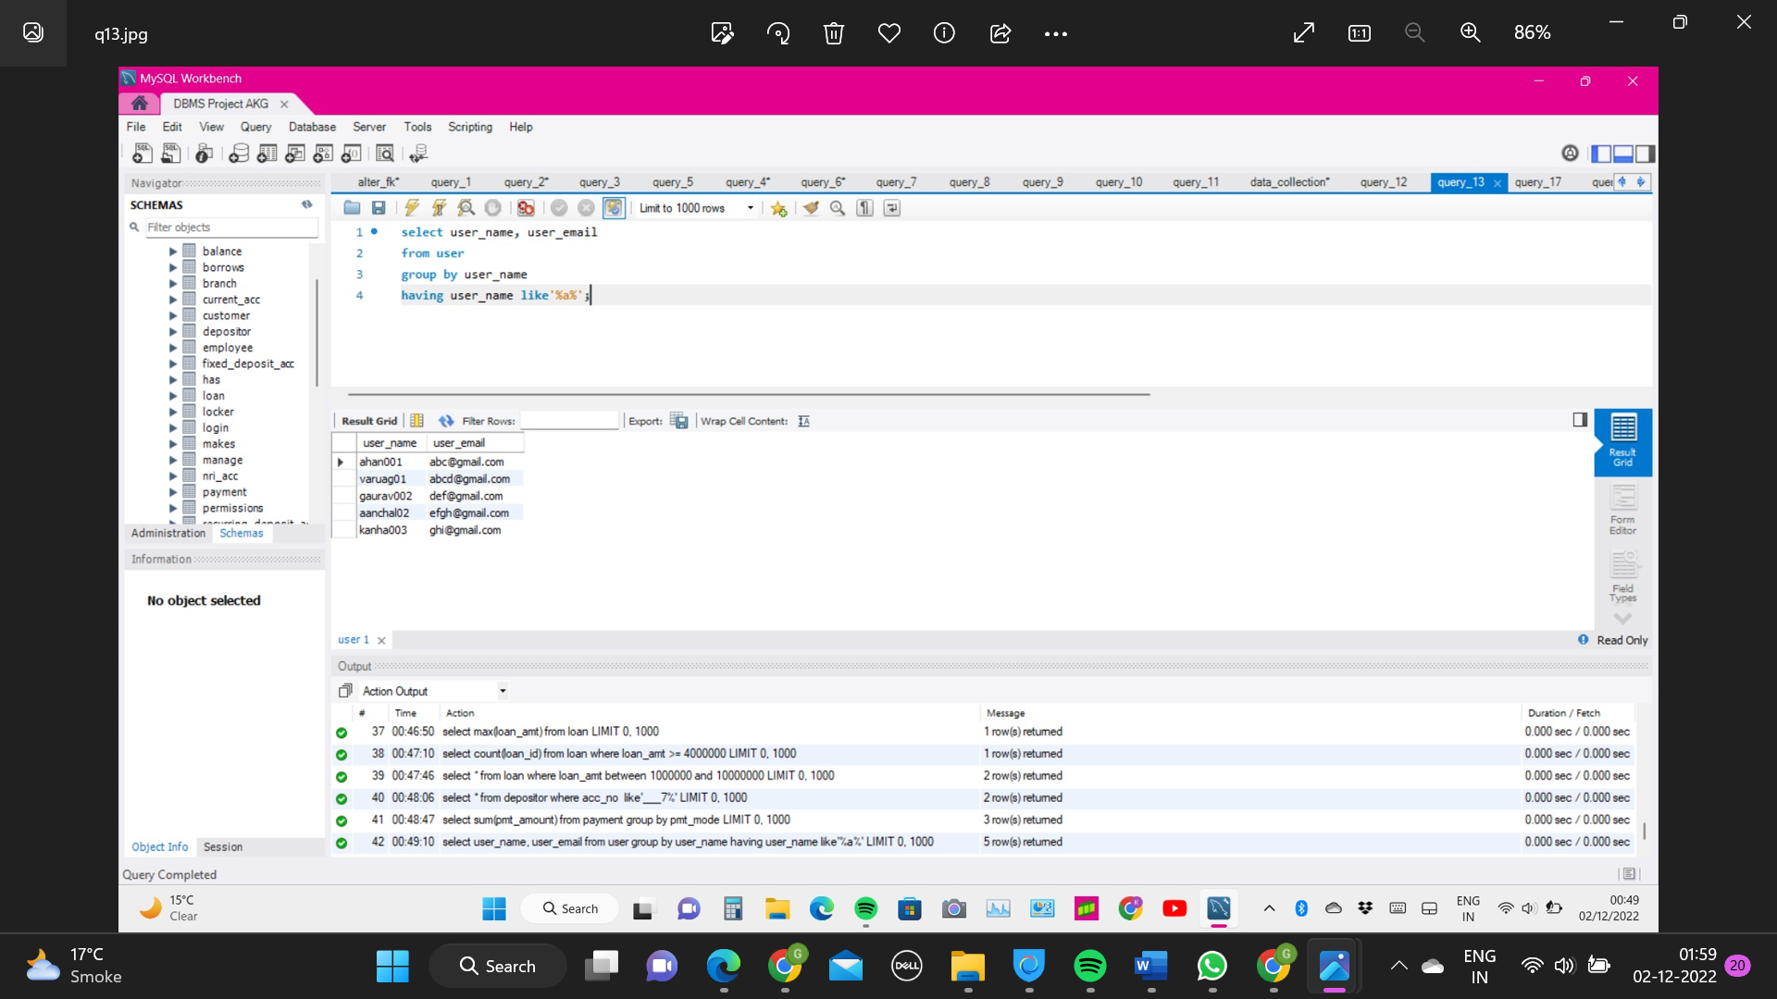

**Question 14:** **Retrieve user data in ascending order of their names**

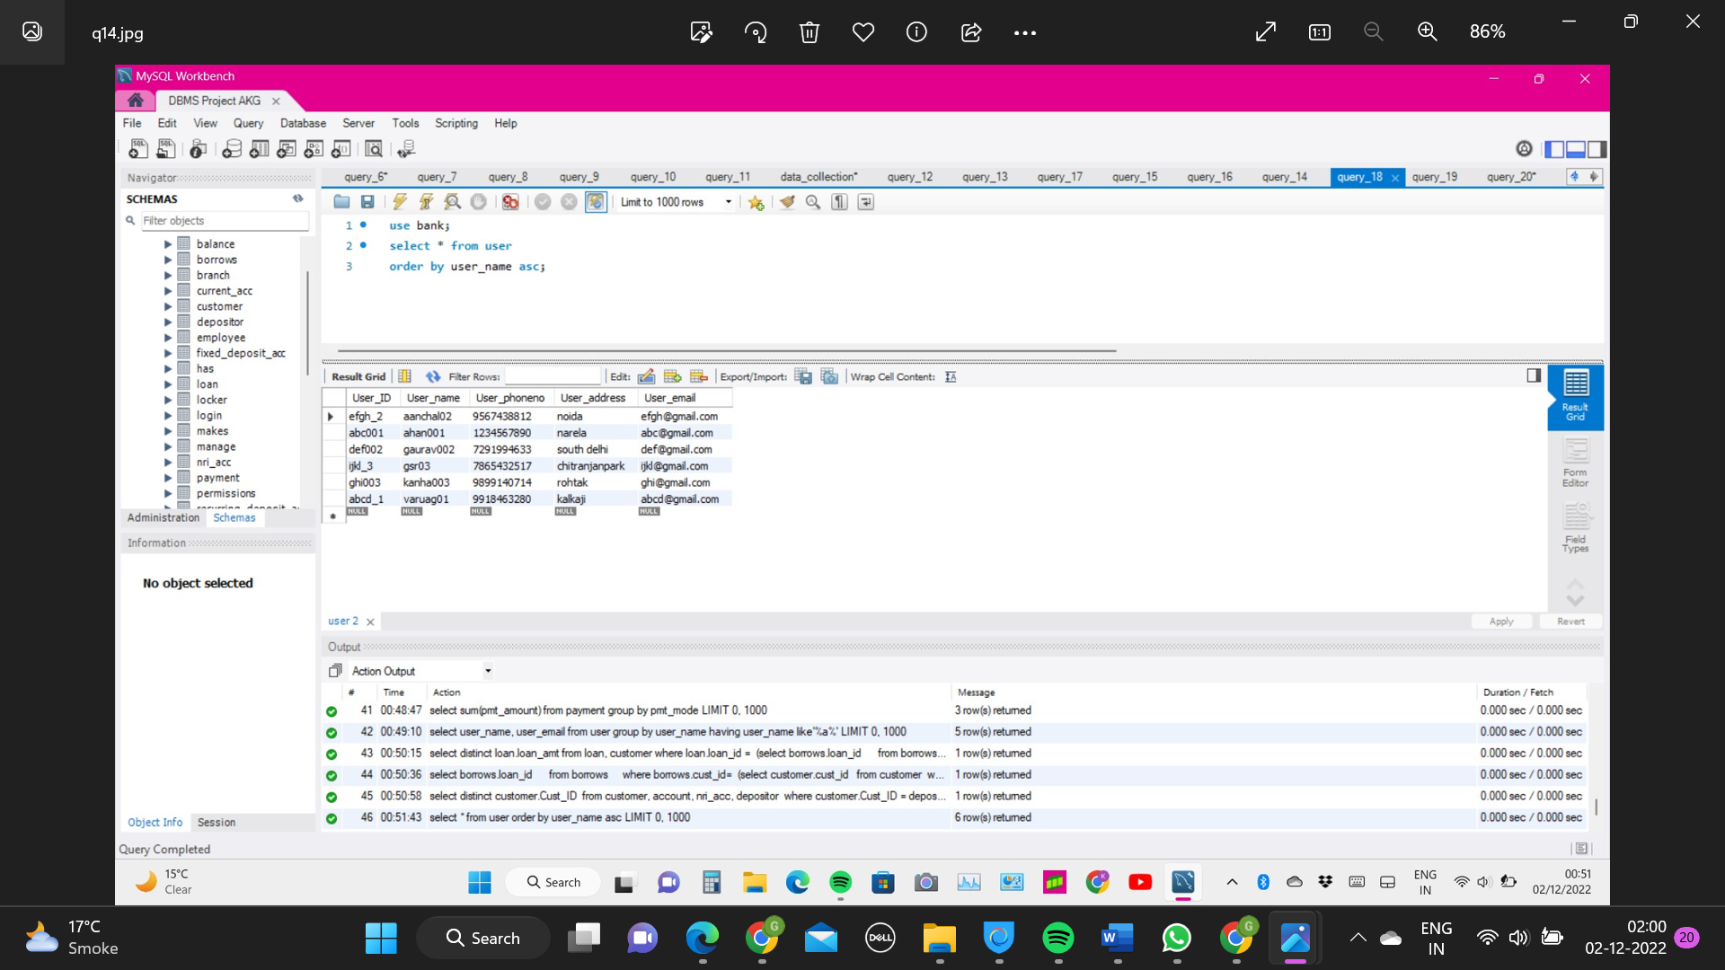

**Advance queries**

**Question 15:** **Retrieve names of all customers who have performed payment via net banking**

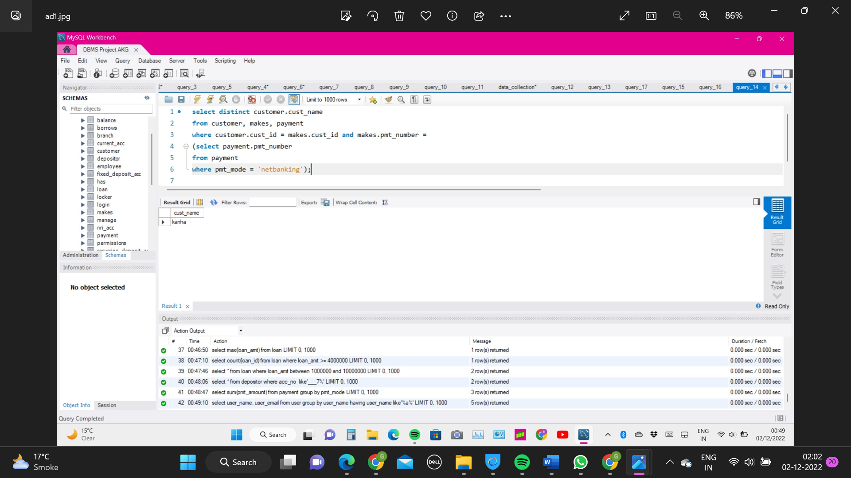

**Question 16:** **retrieve loan amount taken by the customer having locker no. = 123**

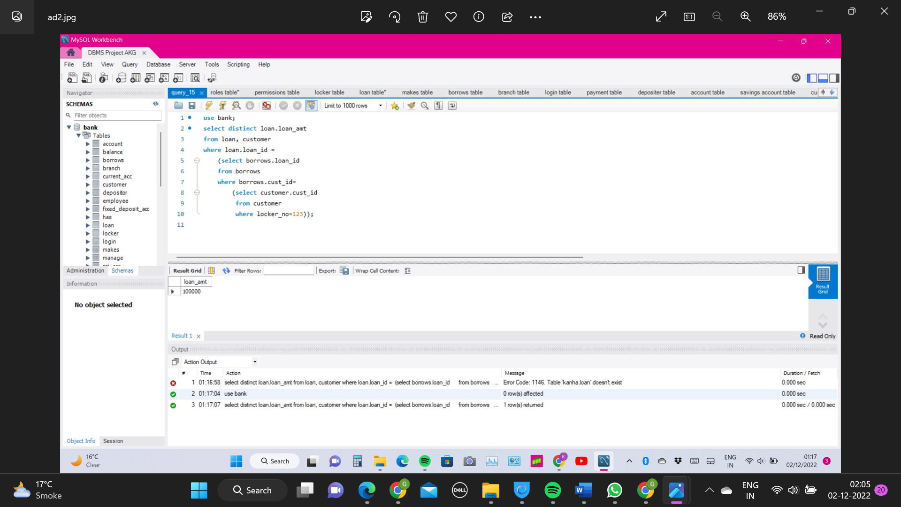

**Question 17:** **Loan details of customer with locker no '123'**

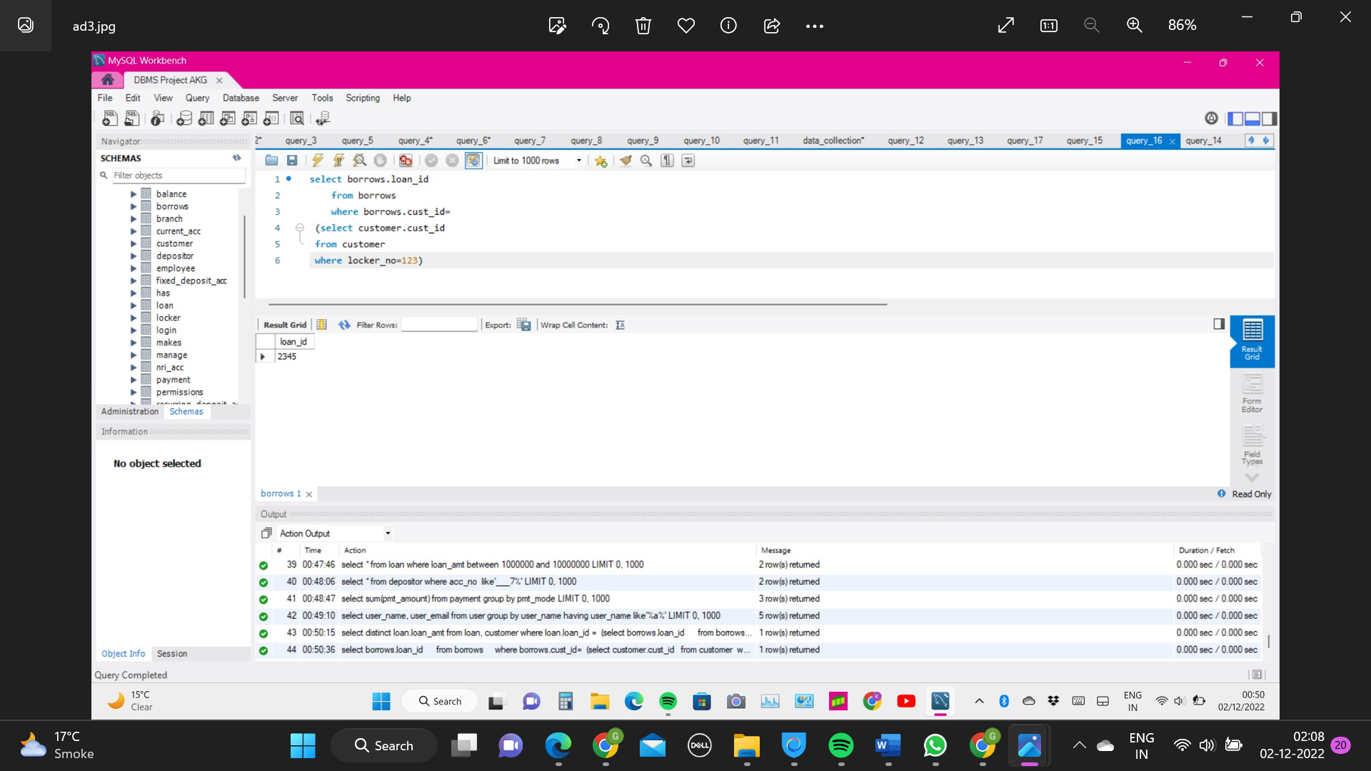

**Question 18:** **Retrieve ID of all customers having account in bank. That are from 'Norway**

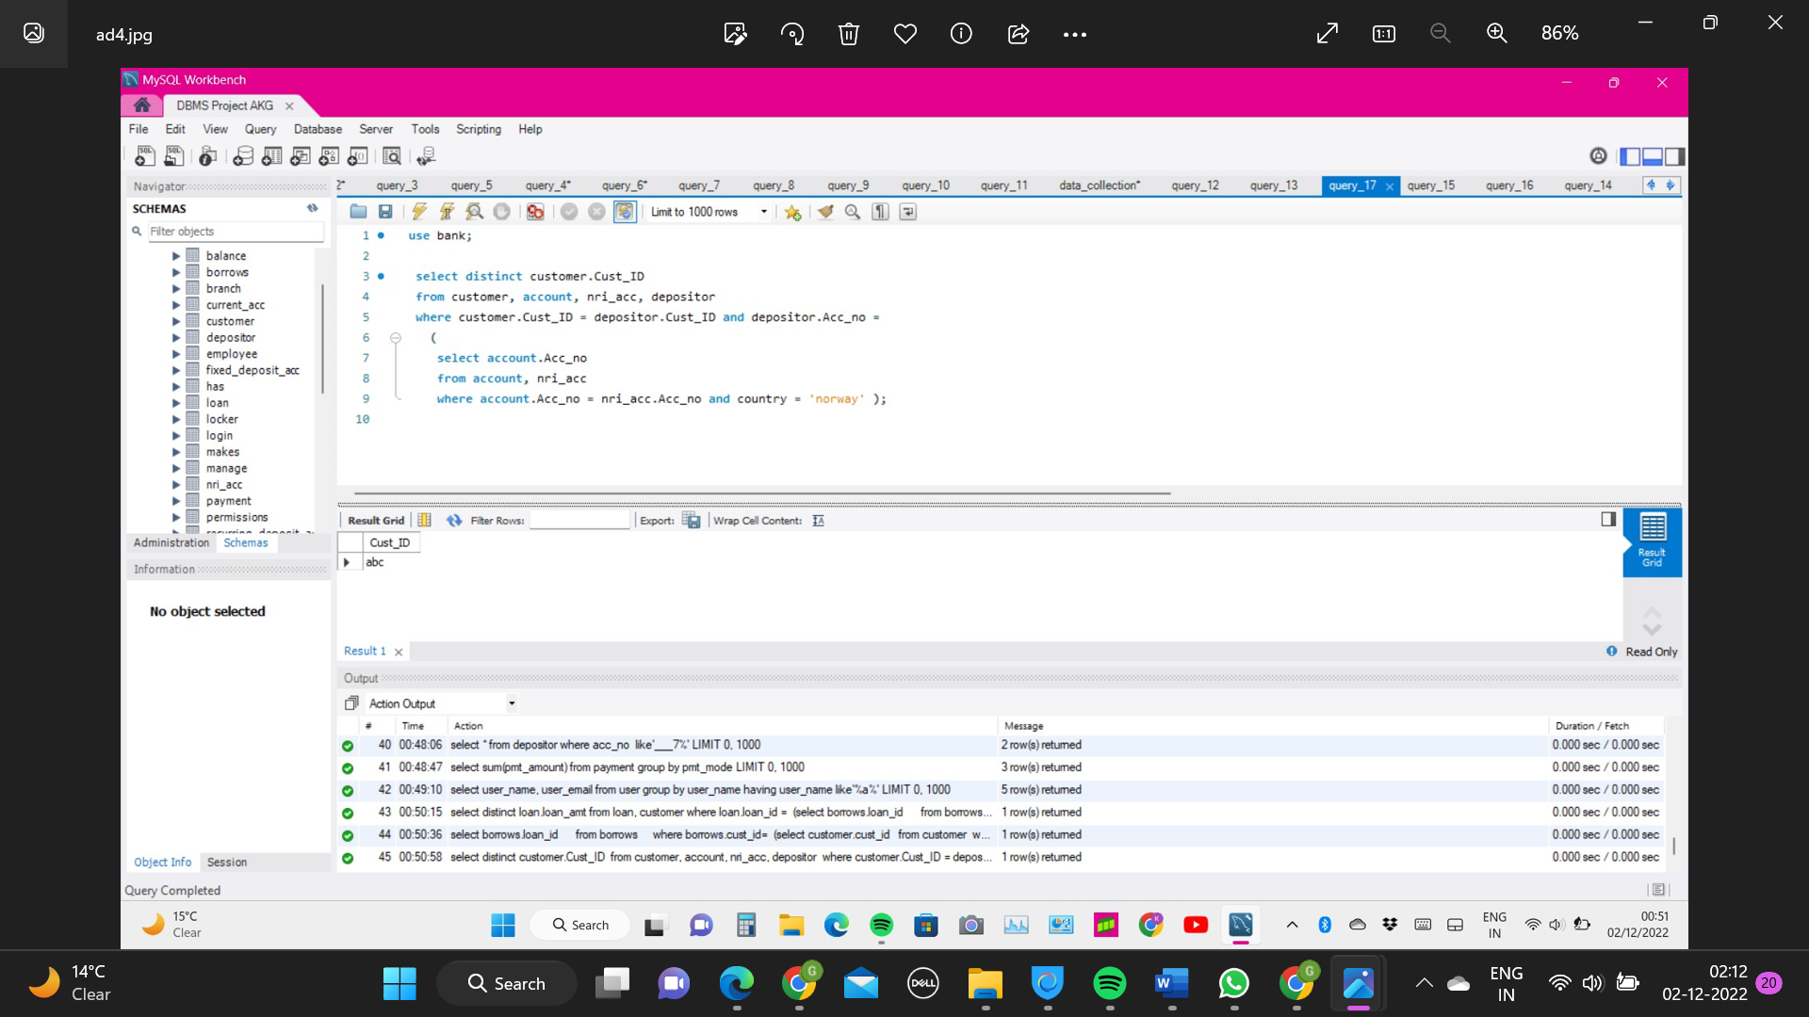

**Question 19:** **Show customer names with their account balance.**

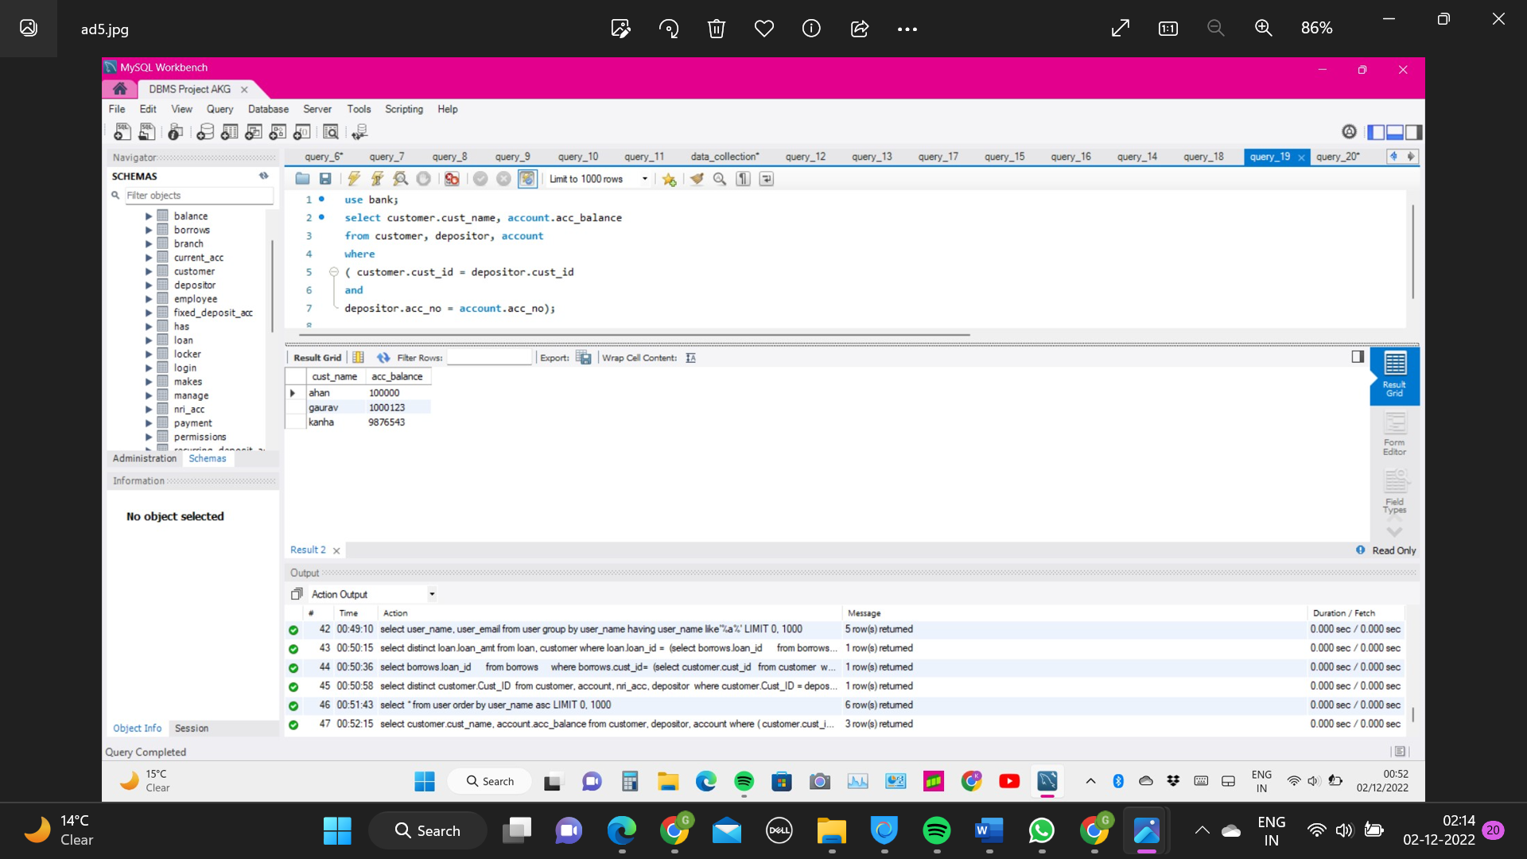

**Question 20:** **Show account balance and account minimum balance limit for customer having id='ghi’.**

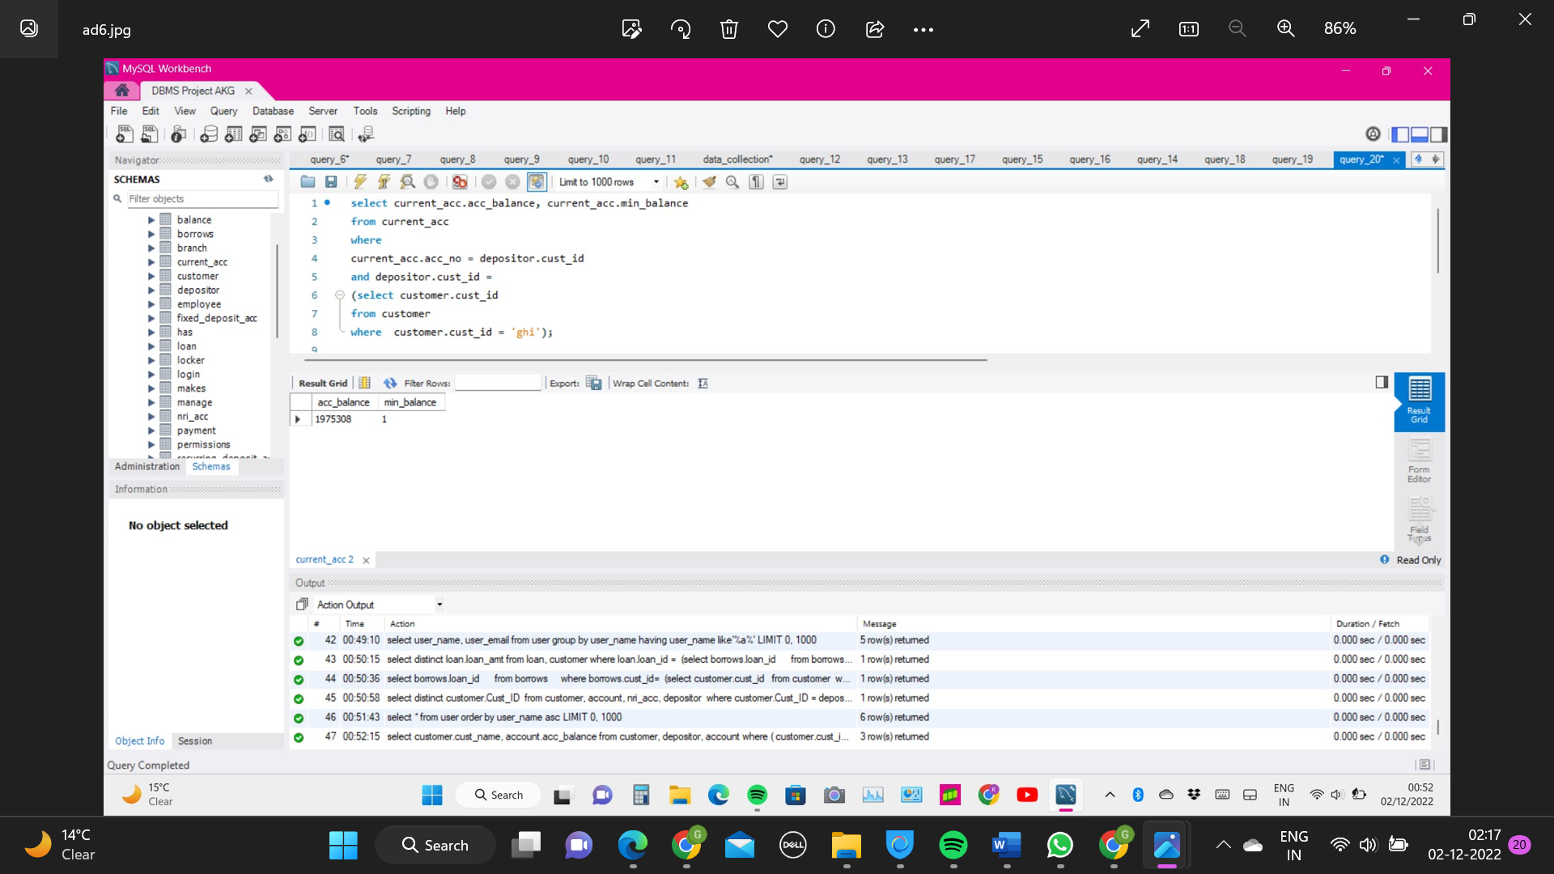

**Front End**

The Front End of the Bank website involves interconnected webpages to form a crude website of Bank of Baroda prototype.

**Tech stack used includes:**

* **HTML**
* **CSS**
* **JavaScript**
* **PHP for connectivity**

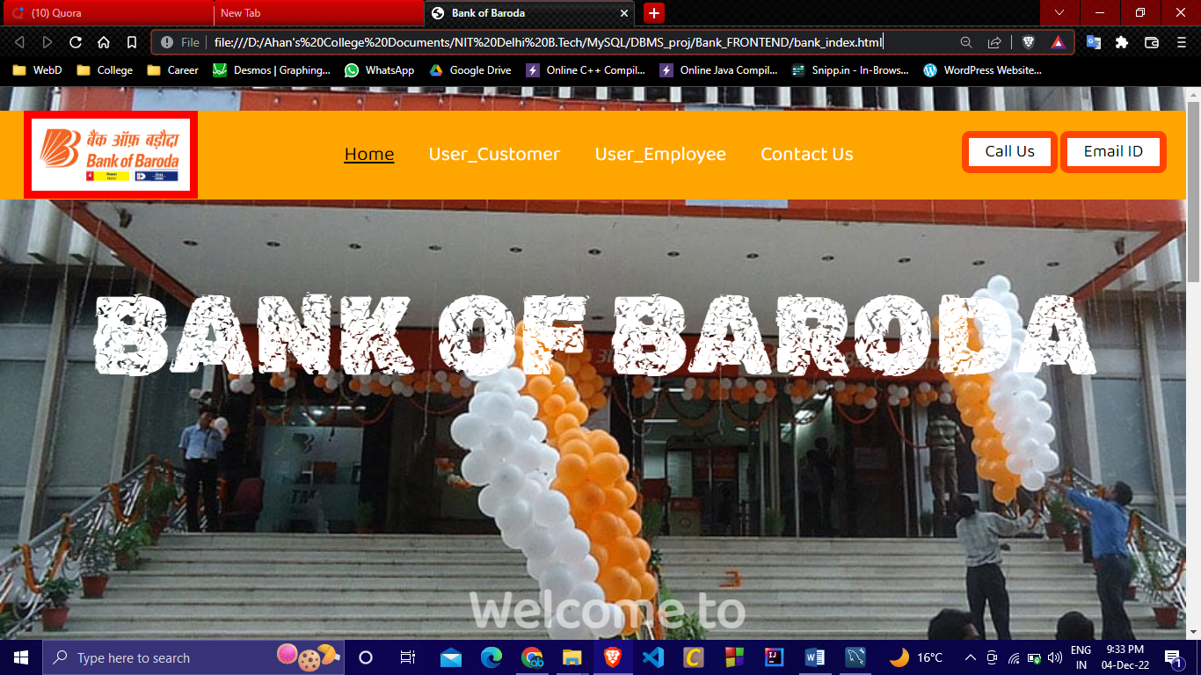

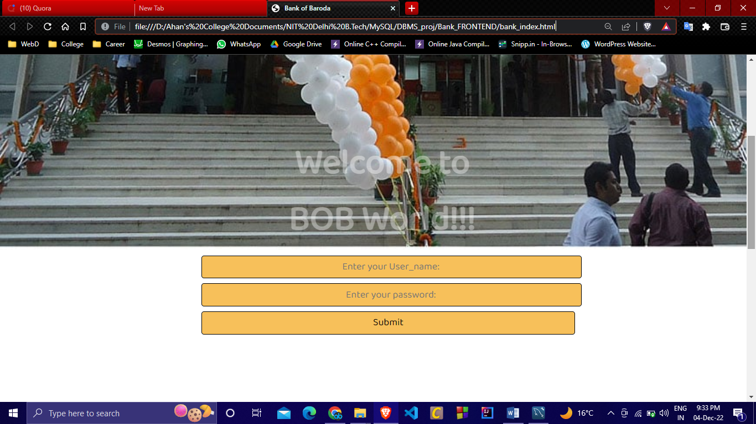

**BIBLIOGRAPHY**

[**https://www.bankofbaroda.in/**](https://www.bankofbaroda.in/)

[**https://www.youtube.com/watch?v=qlLpDBSOe3o**](https://www.youtube.com/watch?v=qlLpDBSOe3o)

[**https://miro.com/**](https://miro.com/)

[**https://www.youtube.com/playlist?list=PLu0W_9lII9agiCUZYRsvtGTXdxkzPyItg**](https://www.youtube.com/playlist?list=PLu0W_9lII9agiCUZYRsvtGTXdxkzPyItg)

[**https://www.w3schools.com/php/php_mysql_connect.asp**](https://www.w3schools.com/php/php_mysql_connect.asp)

[**https://www.cs.purdue.edu/homes/bb/cs448_Fall2017/lpdf/Chapter09.pdf**](https://www.cs.purdue.edu/homes/bb/cs448_Fall2017/lpdf/Chapter09.pdf)